Lesson: Civil Engineering: The Science Behind Bridges
Grade Level: 8-9 – Time Required: 40 minutes – Lesson Dependency: None – Subject Areas:
- Geometry
- Physics

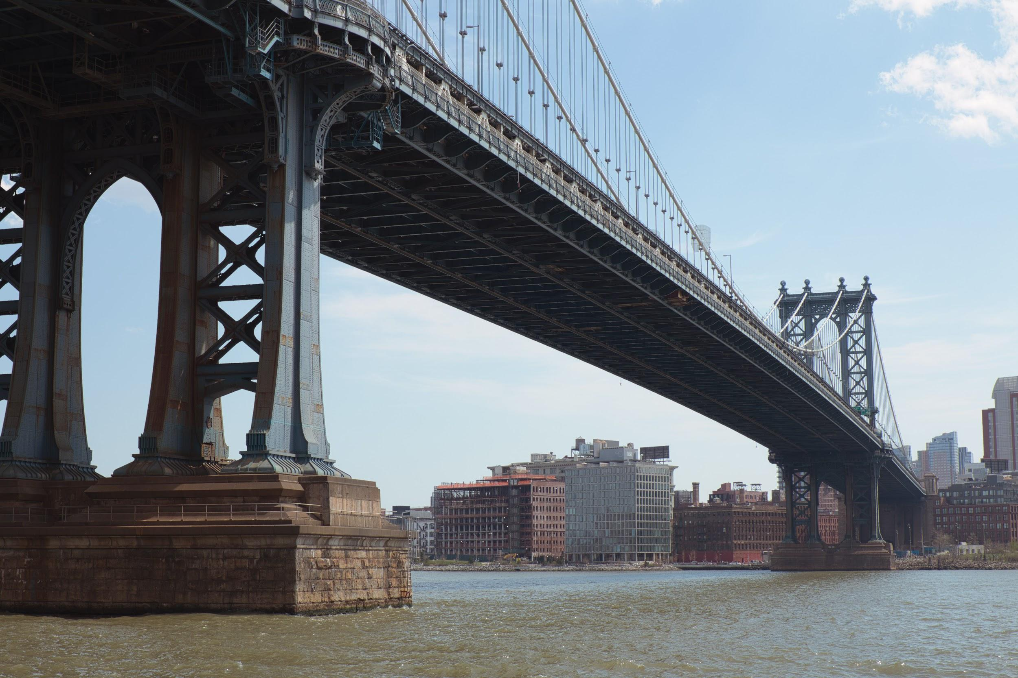
Summary
Students will learn about the nature of bridges and understand the forces and design choices behind them. One of which is the triangle, where it brings such structural strength when compared to other shapes due to its properties. An activity and worksheet follow the lesson and its contents. The activity is a method to expose the students to a firsthand experience of structure, compression, and the forces buildings must endure to be successful. The related worksheet will help review the concepts taught briefly and interactively.
©Copyright: Ivan Karpov on Unsplash

Engineering Connection
Structure is integral across many engineering disciplines. The necessity of a structure or building to support not only its weight, but the weight of its load as well, is universally integral. The attributes a triangle has along with the repercussions of both tension and compression lead to the success of engineering marvels from the Eiffel Tower to even the International Space Station. Through this lesson and the accompanying activities, students will think critically while facilitating a unique perspective through the lenses of an engineer.

Learning Objectives
After this lesson, students should be able to:
- Identify the purpose and use of triangles in structural engineering.
- Identify and explain the forces behind a bridge's strength such as tension or compression.
- Be able to differentiate compression, tension.
- Engage in critical thinking to apply the previous concepts mentioned.
- Observe the forces for themselves during the activity.

Educational Standards
- MAFS.8.G.2.6- Explain a proof of the Pythagorean Theorem and its converse.
- MA.912.GR.1.3- Prove relationships and theorems about triangles. (Angles=180)
- International Technology and Engineering Educators Association- Technology- Infrastructure is the underlying base or basic framework of a system (grades 9-12)
- LAFS.910.SL.1.1- Initiate and participate effectively in a range of collaborative discussions (one-on-one, in groups, and teacher-led) with diverse partners on grades 9–10 topics, texts, and issues, building on others’ ideas and expressing their own clearly and persuasively.

Worksheets and Attachments
- Build-A-Bridge Worksheet
- Presentation Slides (Slides 1-9)

Materials List
- 1 Sheet of paper per student
- Books
- Scissors
- Glue, Stapler, Or Tape

Prerequisite Knowledge
Students should have a basic understanding of geometry and shapes, especially the familiarity with the concept of how many other regular shapes can be lessened into multiple triangles. They should also know the properties of triangles, including its traits surrounding its angles, sides, and the relationship between the two.

The pre-lesson assessment allows the instructor to gauge the understanding of the students before diving into the lesson with a simple question. This opens up conversation and interactivity between the instructor and student. Furthermore, with the awareness of how much the students know, the lecturer can either go in-depth, or simplify the lesson.

Lesson Background and Concepts for Teachers
The text and lessons that follow coordinate with the attached Google Slides Presentation. Starting from slides 1 to 9, each will break down the key objectives in each slide and the points/ideas supporting them and leading to their discussion. You may modify and adapt the examples and explanations to suit your classroom’s needs.

Slide 1 -
To begin the lesson and incite discussion, ask the question “Why do you think civil engineers use triangles in their projects and bridges?” or a similar one. Try to get their participation and their thoughts on the matter and use the picture as an example of how it is used. Allow time to discuss their ideas or hypotheses before continuing.

Slide 2 -
The reason for the triangle’s reputation as the strongest shape is its properties. The relationship between its sides and angles dictate its fortitude. The lecturer can either describe the properties at this time or ask the students if they can recall any before doing so.
One of the important properties the triangle has is the fact that its interior angles must add up to 180 degrees and another more famous property is that the triangle must be coherent with the laws of the Pythagorean Theorem: A²+B²=C². To demonstrate the laws, imagine a square and a triangle. If one were to put force on the axis of a square, the shape would shift and move. If you were to push on the axis of a triangle, the shape would stay the same. This is because the length of the sides of the square may stay the same, but the angles must change.
The triangle sum theorem, which says that the angles must add up to 180 degrees doesn’t allow this. If one were to change the angles of a triangle, then the lengths of the sides would have to change and therefore, the Pythagorean theorem would be violated. Due to its inability to change and move, the triangle is perfect for bridges and trusses, where its constancy is needed. A square would bend and give way, leading to the bridge’s demise.
However, notice the square itself can be changed into a triangle and therefore made stronger. Many other shapes can be reduced to triangles as well. (If the explanation is too complicated or many don’t understand the concepts, try to simplify it or add numerical examples).

Slide 3 -
Now that we know why a triangle is used, we can analyze how bridges and trusses work. A truss is defined as a system of members or beams connected and structured to connect and its purpose is to incur axial force. Axial force is when a force, push or pull is acted on the axis of an assembly or part. One perfect example of this is a pencil. If one pulls or pushes on the sides, they would be incurring axial force and the pencil stays together. Bridges are the same way. Each member works together to distribute the weight and forces like the pencil does.

Slide 4 -
Axial Force has two main distinct forces: Tension and compression. They are the previously mentioned push and pull and they are exact opposites. Tension, which is the pull, can be described as a tug of war or a rubber band being stretched. Compression, also known as push, could be described as crushing a can or squeezing the juice out of a lemon. These two forces are incredibly common and can be seen everywhere, but how are they used concerning bridges?
Slide 5 -
Both tension and compression are used to combat gravity and are constantly acting on the bridges. Looking at the diagram, when a load pushes down on a bridge, the bottom segments are under stress and are under tension. This tension then pulls the top half down making those members under compression. If the forces are distributed enough, they can support the weight and handle the duress.
One prime example of this is the Golden Gate Bridge. The bottom supports are in constant compression due to the weight of the load and gravity, and the wire cables are in tension by being stretched as they pull the bridge up.

Slide 6 -
These concepts are used everywhere in the real world. One example you should know is the Eiffel Tower. (The presenter can ask students if any of them have seen the tower first hand. This can be done to promote their interest or grab their attention.) The tower is 1,063’ tall and 133 years old. The reason why it still stands to this day is due to the strong truss structure used for the supports.
Another example is the International Space Station. The station has solar panels attached by trusses and without them, the station would be powerless. Revolving the Earth at 4.76 miles a second, the solar panels need to be strong to resist the inertia of the movement and any flying debris out in space.
Finally, even our own homes use the structure. Trusses can be found on the inside to support our houses and to make sure they stay standing for years to come.

Slide 7 -
To demonstrate all we’ve talked about, the students will become builders of their own in the Paper Bridge activity. Each student must get 1 sheet of paper and their objective is to make paper supports to stack books on top of. They can choose to make the supports as wide, thick, or tall as they want. They can also wrap the supports together using glue, staples, or tape. Encourage them to be as creative with their arrangement of the pillars and to see who can stack the most amount of books in 10 minutes. As students complete the activity keep track of the one with the most books or the most creative design.

Slide 8 -
To finish, assign the students the Build-A-Bridge Worksheet. It is a simple worksheet to review all that they have learned. They will have to print it out themselves and to complete it to turn it. It also could be used as homework. Then, they can turn it in via email or any other platform as you wish. However, remember that the worksheet is just an example of what you yourself can create and assign to your students.

Slide 9 -
There is an optional break slide if you choose to have it, or you could just move on and not use it.

Associated Activities
Paper Bridge- Students will use one sheet of paper to build and support a tower of books. They can cut and create the pillars whatever shape they want.
Build-A-Bridge Worksheet- Students will complete a simple worksheet to go over and demonstrate the information learned throughout the lesson. The worksheet is just an example of what you can do for your lesson and was created specifically for our purposes.

Lesson Closure
Lesson closure begins after the allotted 15 minutes for Build-A-Bridge Worksheet ends. Hopefully now with their increased understanding behind how bridges and trusses work, students will be able to view the world through an engineer's point of view. Moreover, the basic concepts of tension and compression and its role in the strength of bridges is an important lesson that can be used in future engineering classes.

Vocabulary/Definitions
Truss- a system of members (beams) that are structured and connect in a triangular way.

Axis- The real or imaginary line which something rotates

Axial Force- A force acting along the axis of an assembly

Perpendicular- At an angle of 90° to a given line, plane, or surface.

Tension- The state of stress where an object is being pulled apart

Compression- When an object is being pushed against itself

Load- A heavy or bulky thing that is being carried or is about to be carried

Assessment
Pre-lesson Assessment
The pre-lesson assessment allows the instructor to gauge the understanding of the students before diving into the lesson with a simple question. This opens up conversation and interactivity between the instructor and student. Furthermore, with the awareness of how much the students know, the lecturer can either go in-depth, or simplify the lesson.

During the Lesson
During the lesson, relating the topics to personal experiences could be a great way to interest the students and engage their critical thinking to expand their perspective. One example of this opportunity to do so is slide 6. The slide contains many diverse illustrations: one of which is the Eiffel Tower or the International Space Station. These provide you with ways to relate to the students, asking if they have ever ventured in Paris, France, or wondered about exploring the stars. Another way to get them back into the lesson is by asking inquiries on what would happen if given a certain situation. For example, when presenting the diagram of different

Post-Lesson Assessment
The Build-A-Bridge activity worksheet is a great way to assess whether or not your students have fully understood the key elements of the lesson. The worksheet linked was made for our academy’s summer program, but the template can easily be modified to suit your needs. A simple, yet brain-challenging, worksheet can reinforce the topics gone over while making it feel like less of a task. Consider making your worksheet as it also allows you to determine each student’s progress individually, and it could even be sent as homework to reinforce the topic at home.

Lesson Extension
A way to extend the length or reinforcement of the lesson is through an interactive quiz such as Quizizz, Kahoot, or Nearpod’s climb to the top. All these not only allow for a review of the lesson and its contents, but are also a well-liked method to simultaneously go over the material. What is recommended is to have around 20 questions, each with 30 seconds to answer. After all students have responded or the time runs out, the lecturer has an opportunity to revise the mistakes and further clarify the solution.
Another approach to extend the lesson would be to add an educational video relating to the topic. Periodic and strategic halts in the video would allow the presenter to ask critical thinking questions to rein in the students’ attention. The video could also cause them to grow more interested and implore them to do their independent research on their own.

References
All of the references towards the pictures used during the lesson presentation have the credits in the slide notes.

Dictionary.com. Lexico Publishing Group, LLC.. (Source of most vocabulary definitions, most of which were done in my own words) http://www.dictionary.com
CPALMS Standards and Achievement Standards Network (Source of educational standards) https://www.cpalms.org/Public/search/Standard http://asn.jesandco.org/resources/ASNJurisdiction

Contributors
Abiel Vasallo, Jorge Diaz, Reuben Latorre, Kyle Kamiya, Justin Barroso, Victoria Velazquez, Alex Garrido
Supporting Program
SYIP 2020 Summer Internship Program partnered with the Academy of Engineering at Hialeah Gardens Senior High School.

Acknowledgments
I would like to acknowledge the author(s) of Lesson: Triangles & Trusses. I based the structure of my lesson on the article. I would also like to acknowledge Hialeah Gardens Senior High School for allowing me to write this lesson and conduct the research on it.

Hands-On Activity: Civil Engineering: The Science Behind Bridges: Paper Bridge Activity

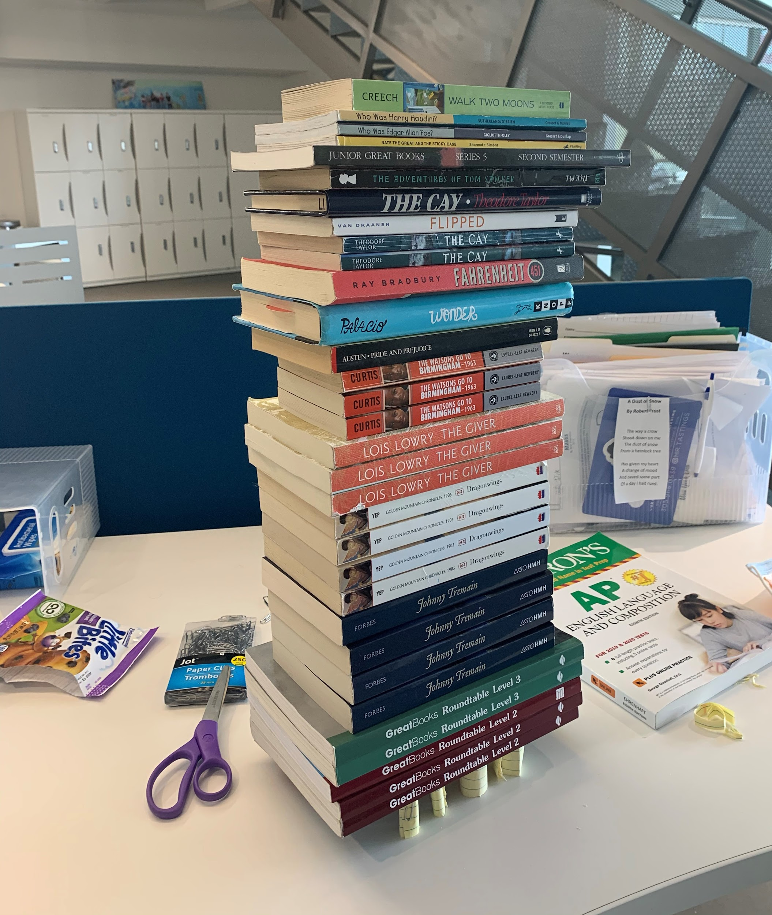
Summary
Students will use 1 sheet of paper to design and create their own system of support for stacks of books. They can change the height, quantity, thickness, width, and placement of the supports. As they stack an increasing amount of books onto their structure, the weight of the load will ultimately crush the supports where then the students can analyze their results and mistakes.

Engineering Connection
Civil engineers design bridges, buildings, and many more architectural marvels we see everywhere. This activity gives the students the freedom to design and critically think which arrangement would be the best. They can personally observe their mistakes and what improvement would have led to a stronger design. Ultimately students can discover the difficulties of designing a working and standing design for themselves.
Courtesy: Hialeah Gardens Senior High

Learning Objectives
After this lesson, students should be able to:
- Explain how different designs lead to different results
- Explain how integral support is.
- Communicate what strategy is the best after observing the activity and contrasting different designs and efforts.

Materials List
- 1 Sheet of paper per student
- Scissors
- Books
- Glue, Stapler, Or tape.

Worksheets and Attachments
- Presentation Slides (Slide 7)

Introduction
Have you ever wondered how many tunnels, buildings, and bridges are still standing? How do their supports hold all that weight and not crumble from the gigantic load placed upon them? Before an idea is implemented into the real world models are used. They help engineers, architects, and scientists alike all find out what the best design for a new project will be. In this activity, you will be the designer of a new structure. Your job is to create your own unique support and then test it out. Both compression (When an object is being pushed against itself), and gravity will be your enemies. Try to see how far you go and how creative you can be!

Procedure
Before the activity:
- Gather a sheet of paper and some scissors.
Students:
- Each will cut up their paper to create their supports.
  - However high, thick, wide, or quantity they desire is up to them
- Roll up each cut of paper into their supports.
- Seal or secure them together with either tape, glue, or staples. (Preference or availability depends on the student)
- Set up the supports in the pattern or arrangement desired.
- Start stacking books on top of the supports.
- Go as high as possible, counting the number of books before it collapsed.
  - Take a picture as you go. It allows you to be able to demonstrate what you were able to accomplish afterward.

Vocabulary/Definitions
Perpendicular - At an angle of 90° to a given line, plane, or surface.

Tension - The state of stress where an object is being pulled apart

Compression - When an object is being pushed against itself

Load - A heavy or bulky thing that is being carried or is about to be carried

Assessment
Pre-Activity Assessment
Class discussion: Ask their opinions on what arrangement they think would be best. What would be the best way to secure their support? What is the best type and shape of pillars?
During the Activity
Have students predict how many books they can hold or engage them by talking about how their progress is so far.
Post-Activity Assessment
Communicate and present each of the students’ towers. (A way to do this is to send the pictures of their towers to an email or a program such as Microsoft Teams to be able to see them all). Then, analyze the faults and successes of their designs. What traits did the strongest designs have? What trait did the weakest have? How did each variable dictate the outcome?

Safety Concerns
- If stacked too high books may fall over and hit someone. Be vigilant and wary of how high and stable your book tower is.

Activity Extension
Expand the parameters of the activity by changing the type of paper, quantity, and quality. Perhaps instead of a paper supported tower, the supports would be solid, leaving the balance and organization as a variable.

Contributors
Abiel Vasallo, Jorge Diaz, Reuben Latorre, Kyle Kamiya, Justin Barroso, Victoria Velazquez, Alex Garrido

Supporting Program
SYIP 2020 Summer Internship Program partnered with the Academy of Engineering at Hialeah Gardens Senior High School.

Lesson: Civil Engineering: Design Process and Drawings
Grade Level: 8-9 – Time Required: 45 minutes – Lesson Dependency: None – Subject Areas:
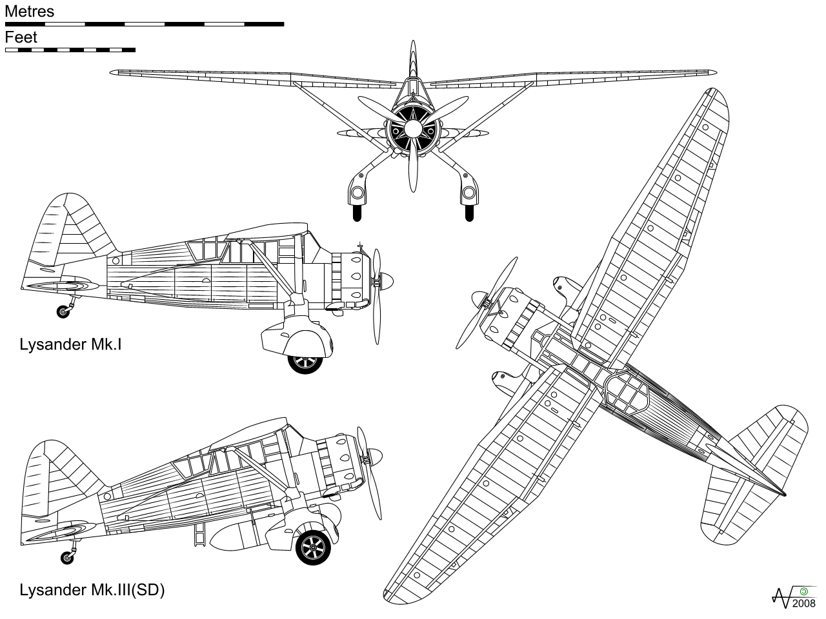
- Science
- Technology
Summary
Students will learn about the thought and innovative process called the Engineering Design Process. The Design Process is used in the manufacturing, designing, and implementation of every idea brought to life. They will first discover the steps and reasoning behind the process. Then, through an educational video, they will analyze and reflect on possible explanations for a bridge collapse. After, students will dive into technical and detailed drawings, which help bring communication between engineers and their ideas. Finally, through an interactive and competitive activity, the students will test their knowledge and grasp of the given learning material.
©Credit: Wikipedia Commons

Engineering Connection
Every idea and concept starts somewhere. The development of that idea into a physical and substantial solution to a problem is where the importance of the design process and drawings shine. Engineers in every field deal with the process and whether the conflict is as simple as a new app or as complicated as rocket science, the design process aids in the nurturing of each possible solution. All the steps included such as identifying the problem, research, brainstorming, testing a prototype, etc., are all realistic steps used in the real world. In addition to the development of an idea through the engineering design process, technical drawings are the main method for communicating ideas, solutions, and courses of action. In the same way that a picture represents 1,000 words, a technical drawing can transmit countless amounts of information from one engineer to another.

Learning Objectives
After this lesson, students should be able to:
- Explain and list the steps of the Engineering Design Process.
- Identify and analyze possible solutions to a problem.
- Identify the purpose behind drawings.
- Be able to define a floor plan and its contents.
- Be able to define a site plan and its contents.
- Differentiate the difference between both site and floor plans.

Educational Standards
- International Technology and Engineering Educators Association- Technology
  - The engineering design process includes identifying a problem, looking for ideas, developing solutions, and sharing solutions with others. (Grades K - 2)
  - The engineering design process involves defining a problem, generating ideas, selecting a solution, testing the solution(s), making the item, evaluating it, and presenting the results. (Grades 3 - 5)
- CTE-TECED.68.ENTECH.11.01
  - Identify the design process involving a set of steps, which can be performed in different sequences and repeated as needed.
- CTE-TECED.68.ENTECH.10.01
  - Use design as a creative planning process that leads to useful products and systems.
Attachments
- Presentation Slides (Slides 1-8)

Materials
- Each student will need a device or computer to participate in the Quizizz activity.

Lesson Background and Concepts for Teachers
The text and lessons that follow coordinate with the attached Google Slides Presentation. Starting from slides 1 to 8. Each will break down the key objectives in each slide and the points/ideas supporting them and leading to their discussion. You may modify and adapt the examples and explanations to suit your classroom’s needs.

Slide 1-
To begin, introduce the topic of the design process and drawings. You may do this by asking a pre-assessment question or by talking about how ideas and concepts are cultivated into real and tangible results through the process. Perhaps you can even take some words or ideas from the “Engineering Connection” section.

Slide 2-
After introducing the topic, explain and introduce the steps of the Engineering Design process.
To begin, everything must start with a question. Whether it is a need, want, or convenience, it all starts with a problem. One example of this is the t.v remote. We wanted the convenience of not having to stand up to change the channel so they invented the remote to do it from our seats. Without a conflict or problem, nothing new would arise.
After you receive a problem, the next step is to do research. Using a book, library, studies, or the internet, investigate if another person has had the same problem as you. If so, what did they do? How did they solve it or what method did they use? Use their information, data, and conclusions to help you in the next section which is brainstorming.
Brainstorming, whether it is with a group or by yourself, is the process of coming up with ideas. This is the time to be creative. Think of every possible way to fix the problem and use your research to enhance your ideas. At the end, choose a possible and tangible concept; meaning it has to be feasible.
The next step is to make a prototype. Make your idea a reality! Once you have created it, test out your prototype and investigate if it accomplishes its purpose. In other words: Does it work? Whether or not it works, there will always be ways to improve and fix it. Which is step 6, identify and record the flaws in your design.
The flaws will then become a new problem to fix therefore leading you to step 7. Repeat the process again with your new problem. Remember that the Engineering Design Process is continuous and always being performed to perfect things. The entire point of the design process is to improve. Examples of this being done are everywhere. Phone companies such as Apple Inc. are constantly improving their devices using this process.

Slide 3-
Now that we know how the process works and what it is, display the video “6 Construction Failures and What We Learned From Them”. This video gives numerous examples of failed bridges and construction plans. This ties into the design process because if something goes wrong, that means that a step in the design process was not done properly. Either it was not tested sufficiently, there wasn’t a proper prototype beforehand, or no improvements were made, something went wrong in the process. The lecturer can pause the video whenever they see fit and ask questions based upon the content or examples given.

Slide 4-
Moving deeper into the design process, technical drawings and architectural drawings are very important parts of the design process. It takes part in the brainstorm and prototype steps. The purpose of these drawings is to communicate ideas. It is a way to display information in an easy to read format and it can be made by hand or electronically. Architects and planners make the drawings and then engineers make sure it is safe and able to be built. In civil engineering, architects have to use these drawings and plans all the time.

Slide 5-
One of the main types of drawings is the floor plan. Like any other plan it displays information, but it is more specific in certain parts. As you can see, it shows information from above. It specializes in the relationships between space, furniture, rooms, and other physical features by giving dimensions and lengths. In the end, it shows all the information of a single floor in a building, but is limited to that floor.

Slide 6-
Another type of drawing is the site plan, which contrasts the floor plan. It is a much broader plan, but still gives a great deal of information. Like the floor plan, it shows information from above, but instead of the relationships between spaces on a floor, it shows the relationships between buildings on the entire property. It can display the whole property, boundaries, entrances, and it can be used to display new construction projects alongside old ones already on the property. Since it is much broader in the information it gives, it does not go into specific and minor details, which is why it is often paired with other drawings and plans.

Slide 7-
Now that we have finished going over the curriculum and learning material, a quizizz is a fun way to review the students’ intake of knowledge and retention of what they learned. After a quiz is chosen or made, simply share the code or link with students and they will compete against each other in real time with the objective to see who can get the best score. As they go through the quiz, the presenter can go over missed questions and reinforce the lesson. For a 15-20 question quiz, the activity should take around 20 minutes.

Slide 8-
To end, ask the students if there was anything that caught their attention or something they learned. This quick activity will hopefully inspire participation and sharing. The lecturer may also choose to further this into a discussion or wrap up the lesson as soon as they want.

Associated Activities
Past Mistakes- While displaying the video titled “6 Construction Failures and What We Learned From Them”, students will learn about historic faults and errors made in the construction of several bridges and the teacher will have opportunities to ask critical thinking questions as well as time to recapture students’ attention.
Quizizz- Quizizz is a site similar to Kahoot, where after a pre-prepared quiz is made to review certain content and topics, students can compete and engage in an activity that encourages them to review what they have learned.

Lesson Closure
Lesson closure begins after the Quizizz class activity ends. Using slide 8, the lecturer can transition into a closing, participating atmosphere where students are asked to share 1 thing they learned or enjoyed from the lesson. Now that they have learned the design process and the basics of technical drawings, the students will be more prepared for future engineering classes and related topics.

Vocabulary/Definitions
Brainstorm - A group discussion to generate ideas or to solve problems

Prototype - A first, typical, or preliminary model of something, especially a machine, from which other forms are developed or copied.

Architectural Drawing - A technical drawing of a building or project with the main purposes of bringing ideas to fruition and communicating ideas or concepts.

Floor Plan - A scale diagram of the arrangement of rooms in one story of a building.

Site Plan - an architectural plan, landscape architecture document, and a detailed engineering drawing of proposed improvements to a given lot. It includes the entire property, buildings, entrances, and more if necessary.

Assessment
Pre-lesson Assessment
As a pre-lesson assessment to gauge the level of knowledge of the students attending the instruction, the lecturer may start the lesson with a question (slide 1). For example, “Does anyone know what the design process is?” is a simple way to encourage participation and at the same time serve as an indicator for their level of familiarity with the topic.

During the Lesson
During the lesson, there are many instances where a quick question or poll would be a good idea to motivate their analytical sides. During the video activity, there are many occasions where one can stop the video and inquire about a certain comment the narrator spoke. For example, one of the named bridge examples (at 2:40) had its supports bending. A good question to start the discussion is to ask for any hypothesis’ or ideas for the cause of the bending.

Post-Lesson Assessment
The final slide, slide 8, is a good post-lesson assessment. The idea behind it is not really to encourage them to think, but just to motivate the students to share something they liked or to just recall something new they encountered or found interesting throughout the presentation.

Lesson Extension
One way to extend the lesson is to include a hands-on activity that the students could partake in. For instance, after discussing and learning of the design process, an assignment could be introduced where the students have to think of a new invention or improved model of a household appliance, and then create a simple drawing or sketch of how it would look like.
Another way to extend their application of what they learned is to give them an example of a technical or engineering drawing and ask what information they can extrapolate from it. This will help reinforce the lesson that the goal of each drawing and plan is to communicate that information.

References
All of the references towards the pictures used during the lesson presentation have the credits in the slide notes.

Dictionary.com. Lexico Publishing Group, LLC.. (Source of most vocabulary definitions, most of which were done in my own words) http://www.dictionary.com
CPALMS Standards and Achievement Standards Network (Source of educational standards) https://www.cpalms.org/Public/search/Standard http://asn.jesandco.org/resources/ASNJurisdiction

Contributors
Abiel Vasallo, Jorge Diaz, Reuben Latorre, Kyle Kamiya, Justin Barroso, Victoria Velazquez, Alex Garrido

Supporting Program
SYIP 2020 Summer Internship Program partnered with the Academy of Engineering at Hialeah Gardens Senior High School.

Acknowledgments
I would like to acknowledge the author(s) of Lesson: Triangles & Trusses. I based the structure of my lesson on the article. I would also like to acknowledge Hialeah Gardens Senior High School for allowing me to write this lesson and conduct the research on it.

Lesson: Civil Engineering: Intro to Architecture
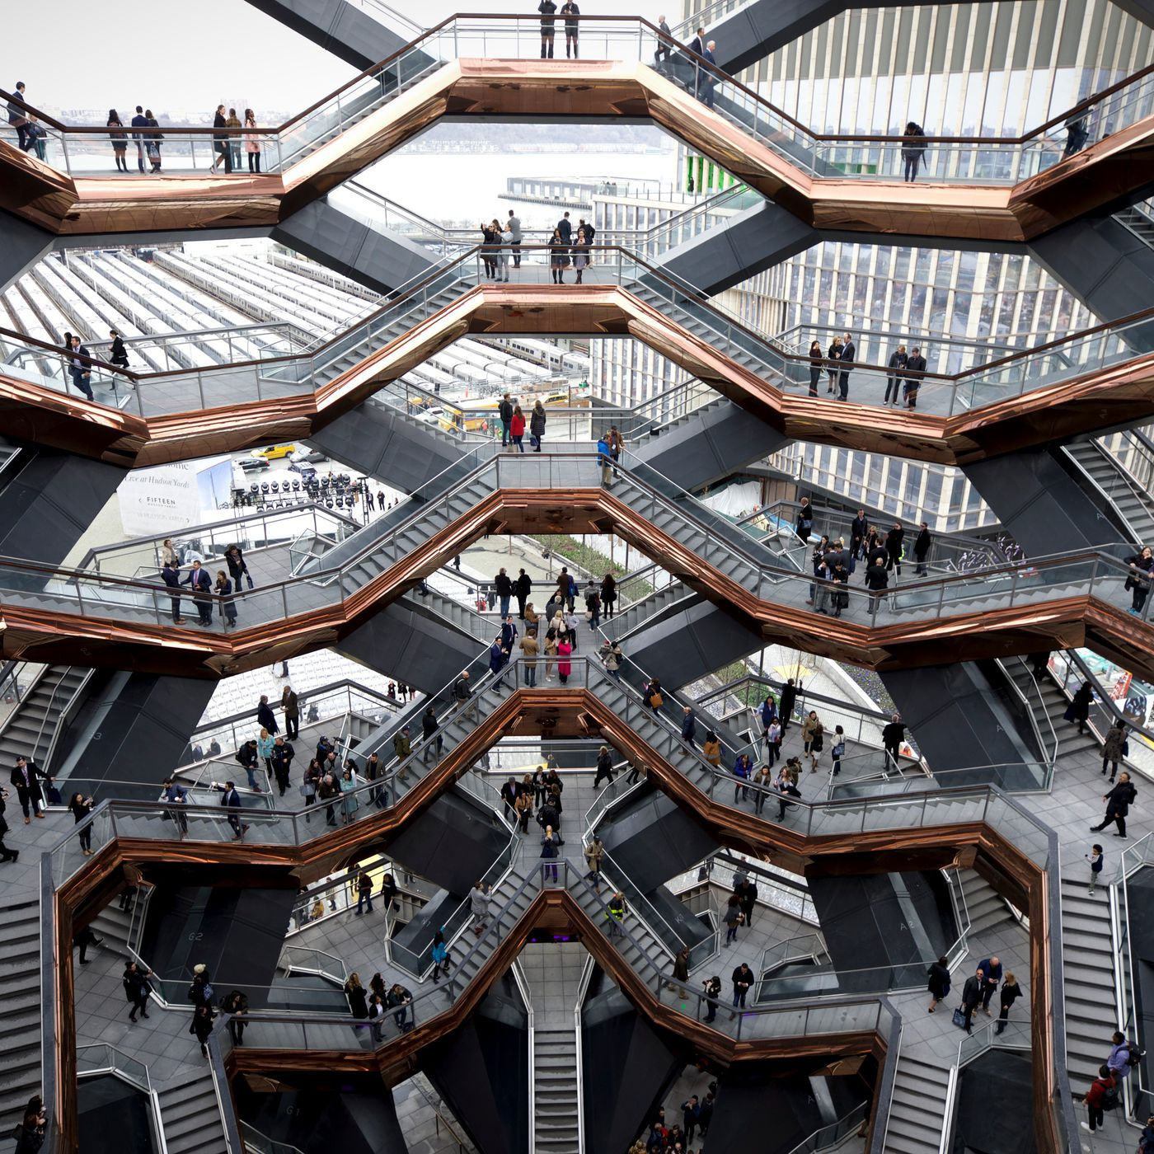
Grade Level: 8-9 – Time Required: 30 minutes – Lesson Dependency: None – Subject Areas:
- Science
- Technology
Summary
Students will learn about what architecture is and what it encompasses. An architect is someone who plans, designs and oversees the construction of buildings and structures. Students will learn how factors dictate and change the parameters of their design. Then they will learn about the architectural advancements surrounding green cities. Finally, students will learn about function and aesthetics and how they’re rivals concerning design. To help reinforce the topic and interact with the students, there will be an activity after where students will search for the weirdest designed building and share it with the class.
©Credit: Caroline Spivak

Engineering Connection
The jobs of both engineers and architects overlap frequently. Both are very engaged in the designing and building of structures we see daily. Every bridge, building, and construction project was made by architects and engineers. While an engineer mainly makes sure that the structure is built to code, is safe, and is exactly as designed, architects design and concern themselves with the plans for the building. Both need to communicate, however, to make sure the structure is built. Using drawings, plans, and more, architects must transmit their ideas.

Learning Objectives
After this lesson, students should be able to:
- Explain what architecture is and what it entails.
- Describe how factors such as cost, codes, function, and area dictate the implementation of a building and its design.
- Explain the relationship between utilitarian design and aesthetics.
- Describe and define a green city.
- Explain the benefits and disadvantages of green cities.

Educational Standards
- International Technology and Engineering Educators Association- Technology
  - The selection of designs for structures is based on factors such as building laws and codes, style, convenience, cost, climate, and function. (Grades 6-8)
  - Structures rest on a foundation. (Grades 6-8)
  - Infrastructure is the underlying base or basic framework of a system. (Grades 9-12)
- VA.912.C.2.8
  - Compare artwork, architecture, designs, and/or models to understand how technical and utilitarian components impact aesthetic qualities.

Attachments
- Presentation Slides (Slides 1-10)

Materials
- Each student will need a device or computer to participate in the Wackiest Scavenger Hunt Activity

Lesson Background and Concepts for Teachers
The text and lessons that follow coordinate with the attached Google Slides Presentation. Starting from slides 1-10. Each will break down the key objectives in each slide and the points/ideas supporting them and leading to their discussion. You may modify and adapt the examples and explanations to suit your classroom’s needs.

Slide 1-
Begin by introducing the topic of architecture. A small introduction of the world around us and the structures encompassing us. Maybe you can take some words from the engineering connection section or start with a question to gauge their interest and to see how much they know of the topic.

Slide 2-
After introducing the topic, define architecture and what architects do. Remember that architects plan, design, and often oversee the construction of their projects. Architecture also differs and changes. For example, both the picture of the castle and the modern house are examples of architecture. Although they look different and have different styles, both were made and designed by an architect.
In the end, what mainly dictates what an architect designs are the different factors and parameters they have.

Slide 3-
Here on this slide, different examples of factors are given. While there are many more, some more specific than others, these are the leading factors when it comes to design. First, define what factors are and then list them. Each of the factors have their example in the form of a picture on the right.
The first is cost. The amount of money and funding a company has will certainly affect the newest design or construction of a new office. When considering a budget, the architect needs to be efficient with the layout.
The area surrounding the new construction project will affect the design. For example, if built in a rural area, there will most likely be plenty of space. In contrast, a more urban area will have less space and the designer has to be conscious of the buildings surrounding it. The landforms such as hills and bodies of water also can change the design.
The purpose of the building changes the design as well. If the purpose of the new project is to contain large quantities of storage it will be big, spacious, and make the most of the space. If the project is for an office, there will most likely be sections, entrances, and exits.
Lastly, building codes will be a major factor in the design of a building. Due to the many standards buildings have to reach to be safe and operable, all the projects have to meet the requirements given. Some of which concerns the materials the building is made of, ventilation, proper exits and sprinklers system, etc.

Slide 4-
Architects have to also keep in mind aesthetics and function. Aesthetics is defined as the way something looks while the function of something is defined as the job or purpose something has to accomplish. These two are clashing and often counterbalance each other. It is the job of the architects to find a balance between the two.
To illustrate this, there are two cars pictured on the right. One is an SUV while the other is a sports car. While both fulfill the purpose of transportation, there are very different benefits and features to each. The SUV is more functional. It has more space, can last longer, takes less gas, and costs less. The sports car, on the other hand, costs more, has less space, and is more fragile, but is more luxurious and looks better.

Slide 5-
Next, we’ll go over Green cities. A Green City is an area designed with consideration towards the social, economic, and the environmental impact of the population. Green cities utilize the land, resources, and infrastructure to diminish the environmental impact of the city.
One way of doing so is by incorporating more trees and plants into the city. It would help the environment and also improve the looks of the city as well. City architects have to plan the city and they can build parks as well as incorporate more plant life into the city. They can also efficiently plan the layout of the city to minimize the amount of land used.
Another example would be green initiatives such as supporting electric cars more or investing in smart transportation systems. These would lessen the use of fossil fuels and emissions and also lower the amount of cars on the road.
Finally, measures to save water would not only save money, but help preserve the water sources nearby.

Slide 6-
To further explain this topic, there are listed positives of green cities. The lecturer can decide how deep they want to go into each and explain them.
One easy benefit is less pollution as explained before. Another benefit is that it fights against environmental degradation. Environmental degradation is the deterioration of the environment, due to the depletion and destruction of the resources around it. The more green a city is, the less they pollute and therefore the less degradation there is. With fewer cars on the road, the air, water, and land quality is elevated.
Continuing with the benefits, the value of the properties and cities that are greener are higher than the ones that aren’t. The more plant life in the area, the more uses it has, and therefore the value is higher. One example of this is rooftop or community gardens. These are easy sources of produce and are great for the environment and the community involved. With a greener city, recycling is promoted. This leads to less waste, less costs for certain products, and less wasted energy.
Finally, with more trees and shrubs in the area, the biodiversity and wildlife in the surrounding area will be higher. This will benefit the birds and animals, giving them homes and preserving their habitats. This relates to green cities because they have to plan, design, and try to integrate this in their drawings. From city roads to public spaces, architects can use these concepts to benefit the community.

Slide 7-
When introducing greener aspects to a city, there is a very big benefit that many can take advantage of. Fluorescent lighting can be expensive, bothersome, and negative to some people’s health. It can cause eye strains and headaches. A more efficient and green approach would be to use normal sunlight. It can conserve energy and heating costs, as well as improve a person's health. It can be therapeutic and it gives important vitamin D. It also helps promote airflow and it makes rooms look bigger, improving the aesthetic.
In the same way, architects can make cities green, they can bring the environmentalist approach to house or office plans. It is on a smaller scale, but architects still take a big part in it.

Slide 8-
The famous landmark of Australia, The Sydney Opera House, is a well known and interesting building. While being unique in its structure and design, the building uses the nearby seawater to help power both its heating and electricity systems. It is an extremely cool feature that had to be both thought of and designed by architects.

Slide 9-
A grand gesture of scientific discovery and progress in the late ’50s, Atomium was built at the 1958 Brussels World Fair. This 335’ tall building has an unusual design. With its nine, iron spheres, the extremely heavy structure is still standing and as strong as ever due to the design of its architects: Jean and André Polak.

Slide 10-
To conclude the lesson, introduce the activity “Wackiest Scavenger Hunt”. Encourage the students to research and find the weirdest and most wacky piece of architecture or building they can find. Once they find it they can share it with the class. The lecturer can choose the amount of time given to find it or maybe assign it as homework. Perhaps when presenting the activity, they can turn it into a competition to see who can submit the most unique one.

Associated Activities
Wackiest Scavenger Hunt- After the examples of two distinct architectural marvels on slides 5 and 6, comes the activity “Wackiest Scavenger Hunt”. The premise is simple, invite the students to do some of their own research and present them with the challenge of finding the craziest, most bizarre architectural constructions and designs. As they find the absurd designs, look at their suggestions with them. You can use this as an opportunity to discuss things such as functionality, cost, and convenience while encouraging discussion and participation.
Design Process and Drawings- Another related lesson I suggest looking into is the “Design Process and Drawings”. The lesson and activities tie into architecture and the basics of how buildings are designed, drawn, and discussed. You can learn more in the “Lesson Extension” section, or investigate it for yourself here.

Lesson Closure
Lesson closure begins after the activity ends. The presenter can choose to have a small class discussion about the topics they learned or they can dismiss the class after naming the winner of the scavenger hunt. The lecturer can also extend the lesson if they choose to do so. Read the “Lesson Extension” section for more ideas or suggestions on how to extend the topic.

Vocabulary/Definitions
Architecture - The art or practice of designing and constructing buildings.

Green Cities - A city designed with consideration for social, economic, and environmental impact.

Ecological - Relating to or concerned with the relation of living organisms to one another and their physical surroundings.

Criteria - A principle or standard by which something may be judged or decided.

Infrastructure - The basic physical and organizational structures and facilities (e.g. buildings, roads, power supplies) needed for the operation of a society or enterprise.

Aesthetic - Concerned with beauty or the appreciation of beauty.

Utilitarian - Designed to be useful or practical rather than attractive.

Assessment
Pre-lesson Assessment
As a pre-lesson assessment to gauge the level of knowledge of the students attending the instruction, the lecturer may start the lesson with a question (slide 1). For example, “Does anyone know what an architect does?” is a simple way to encourage participation and at the same time serve as an indicator for their level of familiarity with the topic.

During the Lesson
During the lesson, there are many instances where a quick question or poll would be a good idea to motivate the students’ analytical sides. When contrasting aesthetics and design, the presenter can choose to ask what some benefits and drawbacks are of certain examples. One example could be an office. What beneficial features does the office have for its function, and what features does the office have that affect its looks.
Post-Lesson Assessment
A mini discussion or question regarding what they learned or liked of the topic could be a great post-lesson assessment. The idea behind it is not really to encourage them to think, but just to motivate the students to share something they liked or to just recall something new they encountered or found interesting throughout the presentation.

Lesson Extension
Consider adding and using the lecture plan “Design Process and Drawings” to further your lesson and to help reinforce the topic of architecture. The lesson goes over the engineering design process, how it is used, its importance, and how drawings are integral in the world of engineering. Those topics can tie in with architecture, as both the design process and technical drawings are essential in the field.
If you choose not to add the “Design Process and Drawings” lecture plan, then contemplate adding another activity such as Kahoot, Quizizz, or Nearpod’s Race to The Top, which are education-friendly sites that aid in the recall and revision of the material taught.

References
All of the references towards the pictures used during the lesson presentation have the credits in the slide notes.

Dictionary.com. Lexico Publishing Group, LLC.. (Source of most vocabulary definitions, most of which were done in my own words) http://www.dictionary.com
CPALMS Standards and Achievement Standards Network (Source of educational standards) https://www.cpalms.org/Public/search/Standard http://asn.jesandco.org/resources/ASNJurisdiction

Contributors
Abiel Vasallo, Jorge Diaz, Reuben Latorre, Kyle Kamiya, Victoria Velazquez, Justin Barroso, Alex Garrido

Supporting Program
SYIP 2020 Summer Internship Program partnered with the Academy of Engineering at Hialeah Gardens Senior High School.

Acknowledgments
I would like to acknowledge the author(s) of Lesson: Triangles & Trusses. I based the structure of my lesson on the article. I would also like to acknowledge Hialeah Gardens Senior High School for allowing me to write this lesson and conduct the research on it.

